

SRI LANKA INSTITUTE OF INFORMATION TECHNOLOGY

[**Enterprise Standards and Best Practices for IT Infrastructure**](http://courseweb.sliit.lk/course/view.php?id=137)

**4th Year 1st Semester 2016 (June Intake)**

Name: N.A.I. Dhanushka

SLIIT ID: IT13136666

Practical Session: <WD >

Practical Number : <Lab 2>

Date of Submission: 30/07/2016

Date of Evaluation : _____________________

Evaluators Signature : _____________________

**Linux**

Select the Amazon Linux

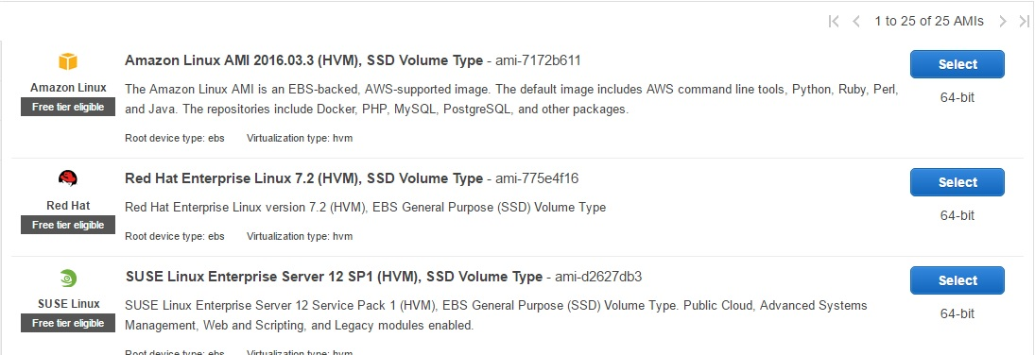

Now click “Review and Launch”

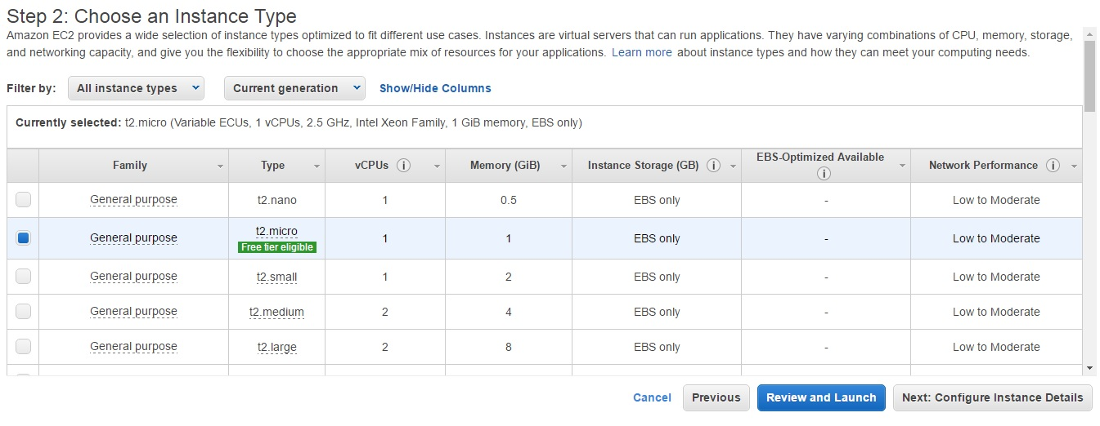

Click “Launch”

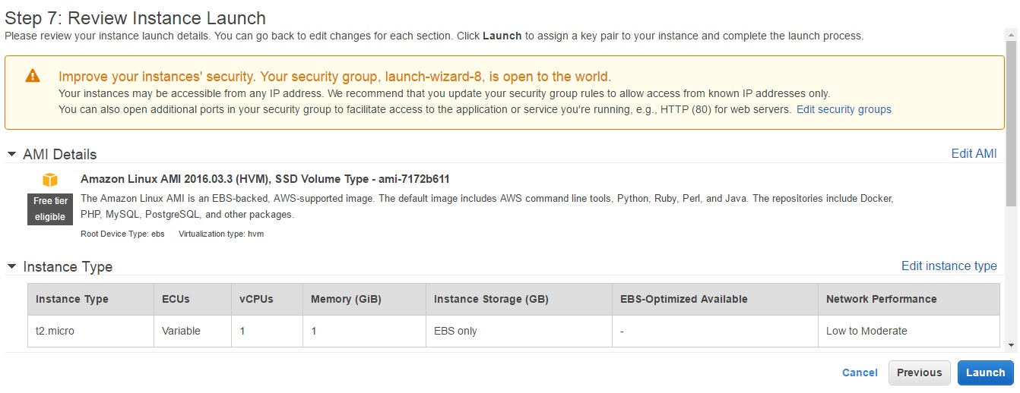

First drop down list we select “Create a new key pair” and give to Key pair name then click “Download key pair”

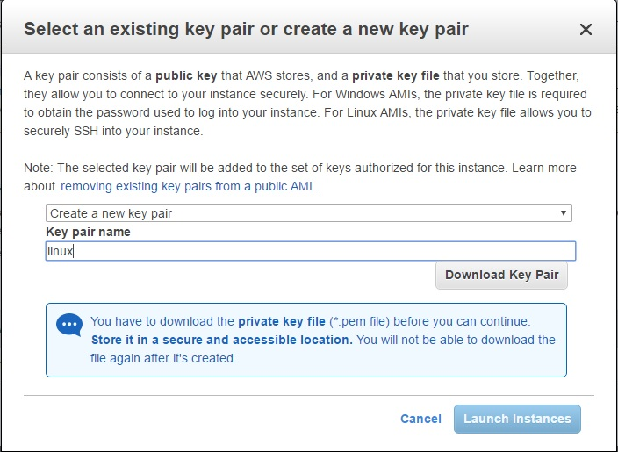

You can see this Launch Status, go to page down

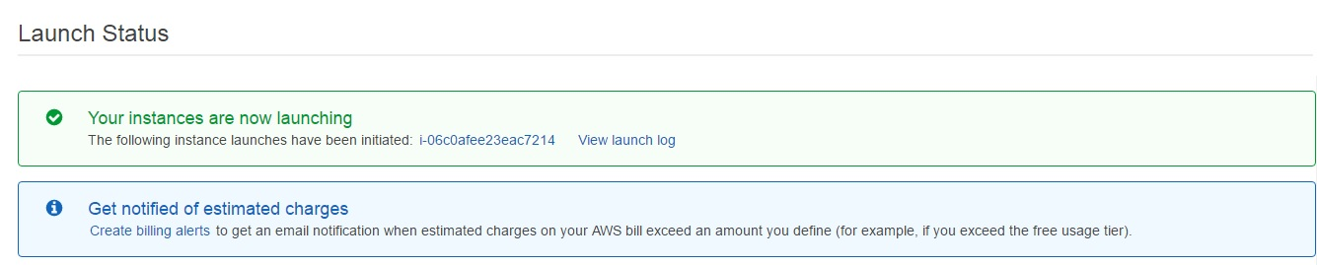

Click “View Instance”

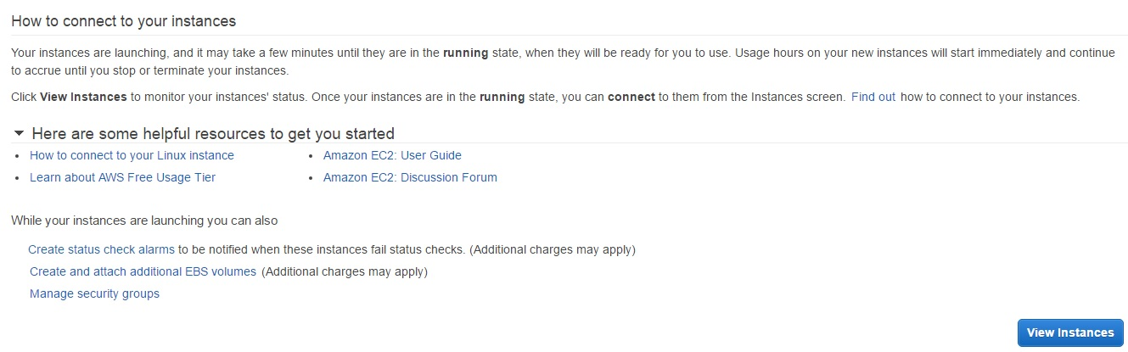

Then tick “Linux Instance” And Click “Connect”

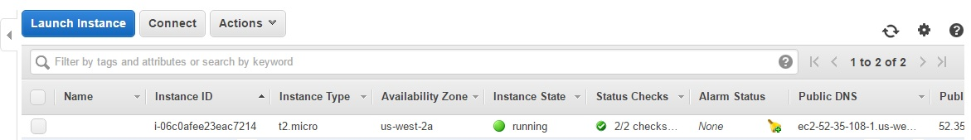

Then you can see Connect to Your Instance window

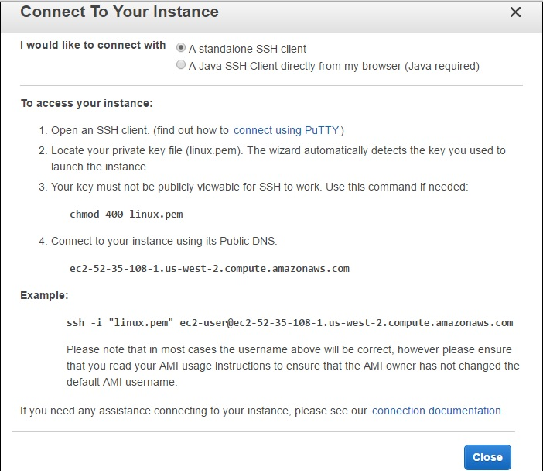

Then run the “PuTTY Key Generator”

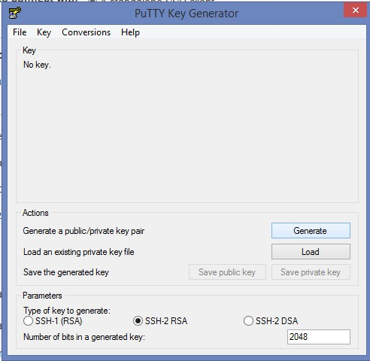

Under Type of key to generate, select “SSH-2 RSA.Click” Click “Load ” select .pem file for the key pair, and then click “Open”. Click “Ok” then click “Generate”

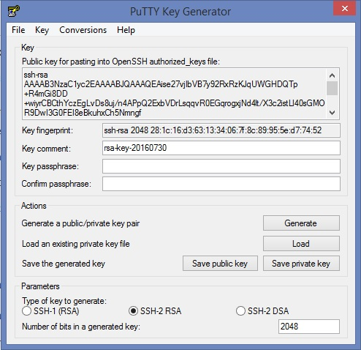

Click “Save Private Key” to save the key in the format than PuTTY can use. PuTTYgen display warning about saving the key without a passphrase. Click “Yes”

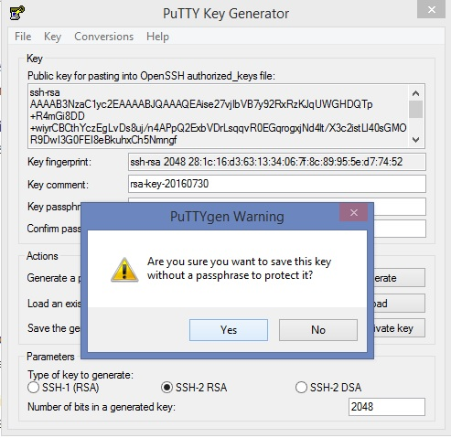

Start the PuTTY, In category pane in the Host name Box enter “Public DNS”

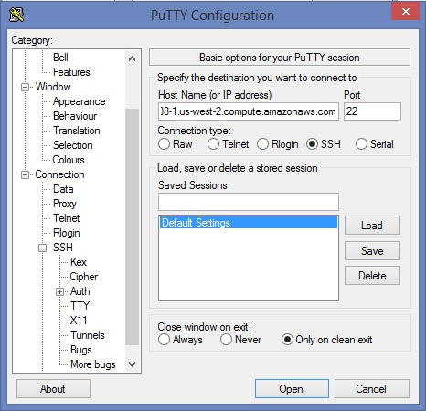”

Under “Connection type” select “SSH”, expand “SSH” and select “Auth”

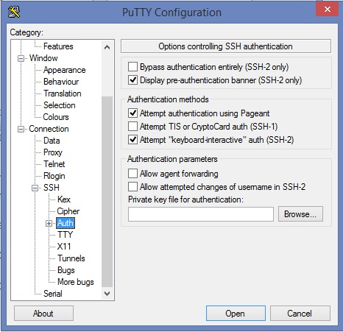

Then go to “Browse” and select the .ppk file that you generate for your key pair and click “Ok”

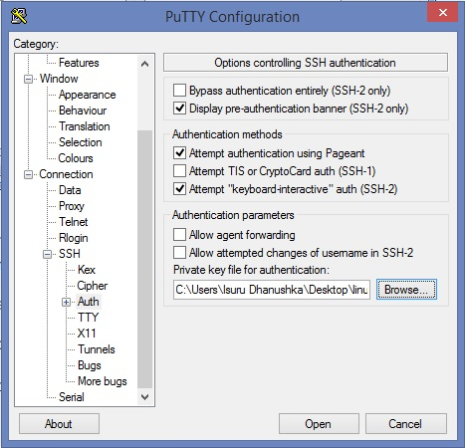

Click “Yes”

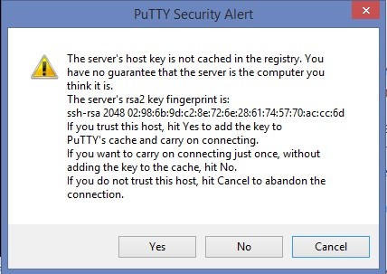

Then

